family, sun, rain hut, teepee, igloo,
apartment, house kitchen garden living room
dining room bathroom bedroom

- Houses protect families from the ____________________ and _________________
- Housing is the place where the________________ live.
- The main parts of a house are ______________________, ______________________, _____________________, ________________________, _______________________, _______________________.
- Different kind of housings ____________________, ______________________ _____________________, ________________________, _______________________,
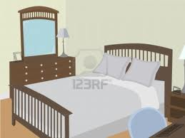
MATCH
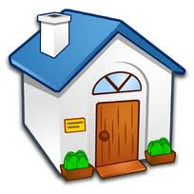
- ______ teepee
- ______ bathroom
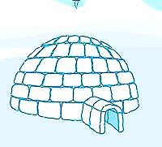
- ______ apartment
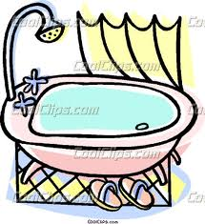
- ______ bedroom
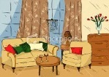
5. ______ kitchen
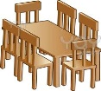
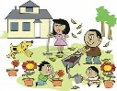
6. ______ house
7. ______ igloo
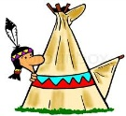
8. ______ hut
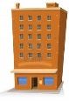
9. ______ dining room
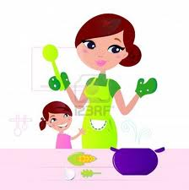
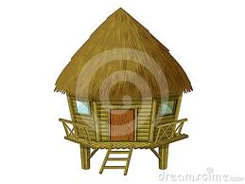
10. ______ living room
11. ______ garden

